Analysis of YOLO Dataset Configuration and Training (COCO8 Dataset).

1. Introduction
In this task, I analyzed the configuration and structure of a YOLO dataset using the COCO8 dataset. COCO8 is a small subset of the COCO dataset used for testing and understanding object detection workflows.
Additionally, I trained a pretrained YOLOv8 model on this dataset and analyzed its performance using evaluation metrics and graphs.

2.Dataset Structure
The dataset follows the YOLO format:

coco8/
├── images/
│ ├── train/
│ └── val/
├── labels/
│ ├── train/
│ └── val/

Observations:
- The dataset is split into training and validation.
- Each image has a corresponding .txt label file.
- Labels contain object annotations.

3.YAML Configuration File (coco8.yaml)
The dataset is controlled using a YAML file which contains:
path → dataset root directory
train / val → image paths
names → class labels

Example:
train: images/train
val: images/val
names: [person, dog, horse, elephant, umbrella, potted plant]

Key Insight:
The YAML file acts as a bridge between dataset and model, defining:
- where data is stored.
- how it is split.
- class mappings.

4.Label File Format
Each image has a .txt file with format:
<class_id> <x_center> <y_center> <width> <height>

Explanation:
- Values are normalized (0–1)
- One line = one object
- Multiple objects → multiple lines

5.Model Training Overview
A pretrained YOLOv8n model was trained on the COCO8 dataset for 10 epochs.
Since COCO8 is a very small dataset, it is mainly used for testing and understanding the training pipeline rather than achieving high accuracy.

6.Training Results Analysis
From the generated graphs:

Precision - Recall Curve
- mAP@0.5 ≈ 0.686
- Some classes (dog, umbrella) show very high accuracy (~0.99)
- Others (horse, elephant) show lower performance (~0.49)

F1-Confidence Curve
- Best F1 ≈ 0.46
- Optimal confidence ≈ 0.125

Confusion Matrix
- Sparse predictions
- Few correct detections

Loss & Metrics Graph
- Loss values fluctuate
- No smooth convergence
- Recall slightly decreases
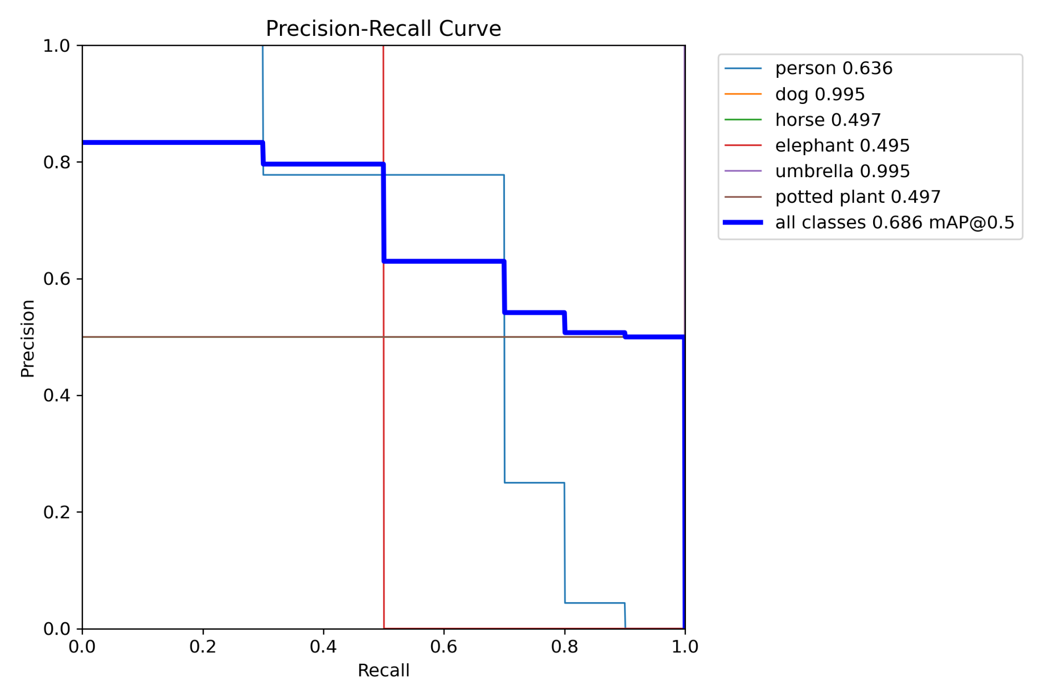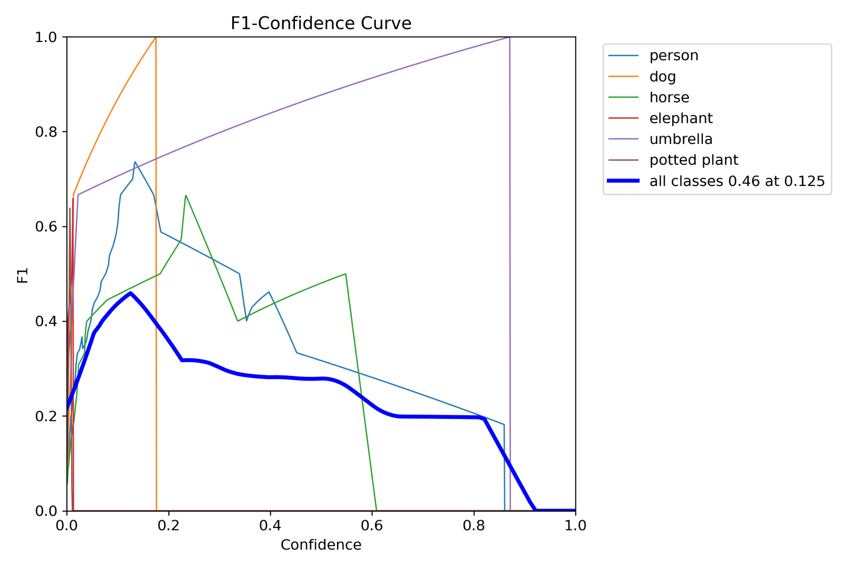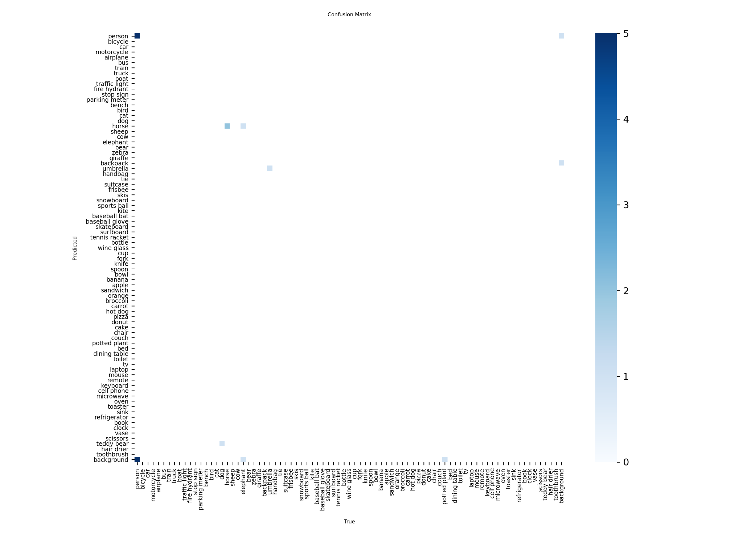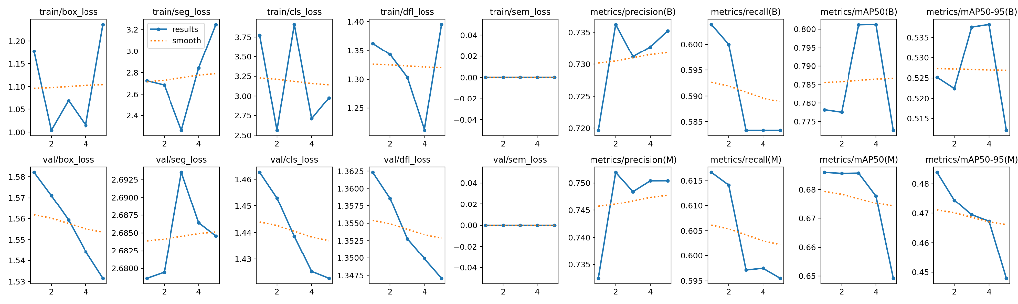
7.Key Observations
- Dataset structure is well organized.
- YAML file defines dataset configuration.
- Labels use normalized coordinates.
- A small dataset leads to unstable training.
- Performance varies across classes.

8.Importance of Configuration Files
- Ensure correct dataset loading.
- Define class labels.
- Enable easy training setup.
- Maintain consistency across YOLO models.

9.Conclusion
This task helped me understand both dataset configuration and model behavior. The YAML file defines dataset structure, while label files provide object details. Training on COCO8 showed moderate performance due to limited data and epochs. Larger datasets and longer training would improve results significantly.

10.References
- https://docs.ultralytics.com
- ⁠https://docs.ultralytics.com/datasets/detect/coco8/
- https://github.com/ultralytics/ultralytics⁠

